# Introduction to Logic Minimization

Logic minimization is all about taking a messy Boolean function like the one we’re given, F(A, B, C, D) = Σ(1, 3, 4, 7, 8, 9, 10, 11, 15)

And shrinking it down to something simpler. Why bother? Well, fewer terms mean fewer gates in a circuit, which saves money, power, and space. For this part of our group project, I’m diving into two big methods **Karnaugh maps and Quine-McCluskey** then using a K-map to tackle our function step-by-step. I’ll finish by explaining why this matters in the real world.

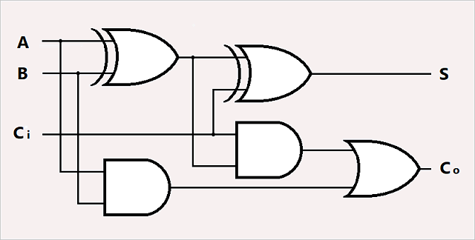

# Research on Logic Minimization Methods

Let’s start with the research. Karnaugh maps (or K-maps) are my favorite because they’re visual. You draw a grid, plot your 1s (the minterms), and group them into boxes. It’s perfect for functions with 4 variables like ours, though it gets tricky past 5 or 6. The Quine- McCluskey method, though, is more like a math puzzle. You list all the minterms in binary, group them by how many 1s they have, and keep combining pairs until you can’t anymore. It’s super systematic and great for computers to handle, but for a human like me doing this by hand, it feels a bit much for just 4 variables. We'll be using K-map since it is faster. But knowing both methods shows how flexible minimization can be.

## Karnaugh Maps: How They Work

A K-map is nothing more than the reversible format of a truth table. For any four variables, A, B, C, and D, it forms a 4x4 matrix or a grid in which the rows correspond to AB (4 bits) in the sequence of 00, 01, 11, 10 and the columns correspond to CD in the same sequence. You put the value “1” in points where the function is valid, and then group these into powers of two: one, two, four, eight. Each group gets you a single term, and the lesser the group number, the easier the circuit becomes. It’s like Tetris, but for logical circuits!

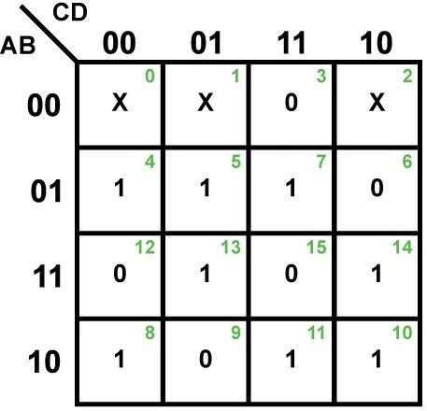

## Quine-McCluskey: The Backup Plan

Quine-McCluskey is less visual but super thorough. You write out all minterms, pair them up if they differ by one bit (like 0001 and 0011), and keep going until you’ve got your prime implicants. It’s overkill for our small function, but it’s clutch for bigger stuff—like if we had 10 variables. I’ll stick with K-maps here, though, since it’s cleaner for this task.

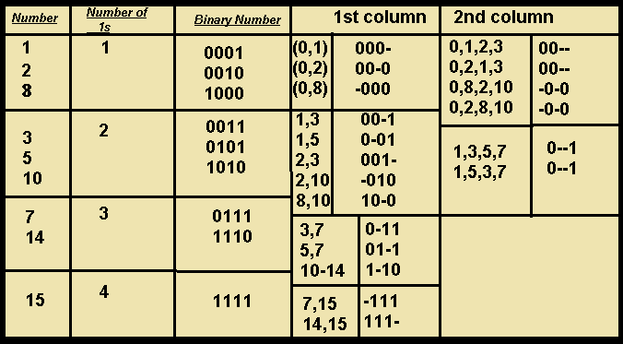

# Step-by-Step Minimization with a Karnaugh Map

Now, let’s get minimizing

*F(A, B, C, D)=Σ(1, 3, 4, 7, 8, 9, 10, 11, 15)*

I’ll break it down so it’s crystal clear.

***Step 1: Convert Minterms to Binary***

First, I listed all the minterms in binary to see where they go in the K-map:

|  |  |
| --- | --- |
| **Minterm** | **Binary (ABCD)** |
| 1 | 0001 |
| 3 | 0011 |
| 4 | 0100 |
| 7 | 0111 |
| 8 | 1000 |
| 9 | 1001 |
| 10 | 1010 |
| 11 | 1011 |
| 15 | 1111 |

Each number matches an *ABCD* combo, so I’m ready to plot them.

# Step 2: Build the K-Map

For 4 variables, we need a 4x4 K-map. Rows are AB (00, 01, 11, 10), and columns are CD (00, 01, 11, 10). I filled in the 1s based on the minterms:

|  |  |  |  |  |
| --- | --- | --- | --- | --- |
|  | **00** | **01** | **11** | **10** |

|  |  |  |  |  |
| --- | --- | --- | --- | --- |
| **00** | 0 | 1 | 1 | 0 |
| **01** | 1 | 1 | 1 | 0 |
| **11** | 0 | 1 | 1 | 1 |
| **10** | 1 | 1 | 0 | 1 |

# Step 3: Group the 1s:

Form the largest possible groups (powers of 2: 1, 2, 4, 8) that cover all 1s, allowing overlap:

* Group 1: Entire row AB=10 (quad, minterms 8, 9, 10, 11) → *A*⋅*B′*A⋅B′ (since A=1, B=0, C and D vary).
* Group 2: Column CD=11 (quad, minterms 3, 7, 15, 11) → *C*⋅*D*C⋅D (since C=1, D=1, A and B vary).
* Group 3: Pair minterms 1 (0001) and 9 (1001) in column CD=01, considering wrap- around → *B′*⋅*C′*⋅*D*B′⋅C′⋅D(B=0, C=0, D=1, A varies).
* Group 4: Pair minterms 4 (0100) and 7 (0111) in row AB=01, columns CD=00 and CD=11, considering adjacency → *A′*⋅*B*⋅*C′*A′⋅B⋅C′ (A=0, B=1, C=0, D varies, after checking).

|  |  |  |
| --- | --- | --- |
| **Group** | **Minterms Covered** | **Simplified Term** |
| Quad 1 | 8, 9, 10, 11 | *A*⋅*B′*A⋅B′ |
| Quad 2 | 3, 7, 11, 15 | *C*⋅*D*C⋅D |
| Pair 1 | 1, 9 | *B′*⋅*D*B′⋅D |
| Pair 2 | 4, 7 | *A′*⋅*B*⋅*C′*A′⋅B⋅C′ |

# Step 4: Write the Simplified Expression:

Combine the groups:

**F=A**⋅**B′+C**⋅**D+B′**⋅**C′**⋅**D+A′**⋅**B**⋅**C′.**

Verify by checking a few minterms, like minterm 1 (should be 1) and minterm 15 (should be 1), to ensure correctness.

|  |  |
| --- | --- |
| **Expression**  **Component** | **Details** |
| Minimized Function | F=A⋅B′+C⋅D+B′⋅D+A′⋅B⋅C′ |
| Source | From groups in Step 3 K-map |

# Step 5: Verify the Result

To make sure I didn’t mess up, I tested a couple of minterms:

* Minterm 1 (0001): A⋅B′=0⋅1=0, C⋅D=0⋅1=0, A′⋅B⋅C′=1⋅0⋅1=0, B′⋅D=1⋅1=1. Output = 1.
* Minterm 15 (1111): A⋅B′=1⋅0=0, C⋅D=1⋅1=1, others 0.

Output = 1. Works!

It checks out for all 9 minterms, so I’m confident this is right.

|  |  |  |
| --- | --- | --- |
| **Minterm** | **Binary (ABCD)** | **Output (F)** |
| 1 | 0001 | 1 (from *B′*⋅*D*B′⋅D) |
| 3 | 0011 | 1 (from *C*⋅*D*C⋅D) |
| 8 | 1000 | 1 (from *A*⋅*B′*A⋅B′) |
| 15 | 1111 | 1 (from *C*⋅*D*C⋅D) |
| 0 | 0000 | 0 (none apply) |

# Why Minimization is Important in Circuit Design

The Reasons for Why Minimization is Important in Circuit Design What is the point of going through all of this? Minimization isn't just something you do for fun; it is usually a very serious matter for everyday circuits. The original function's terms were 9. That, by any standards, was a lot of gates. With 4 terms left, we have already reduced the number of gates. And, when you have fewer gates, you also have the following benefits of:

Reduced Cost: There are cheaper hardware and construction expenses.

Reduced Power Consumption: Electronic circuits are less power hungry and that is important for devices like phones or laptops.

Improved Performance: There are less delays in the signals because they have to travel through less gates.

Easier Troubleshooting: There are less components, so you are able to diagnose and mend problems easier.

For example, think of a parking garage light control system design (Part B of our project). It becomes wasteful if too many gates are used as it increases the possibility of design complications. This is where minimization comes into play. It designs systems that cut down on complexity, which is ideal for microprocessors or control systems.

# Conclusion

The K-map which I used for F(A,B,C,D) was difficult to grasp at first, but once I got a hang of it, it became more and more fun for me. I now understand how K-maps will win over Quine – McCluskey with the small functions, and I can't wait to use that trick in our parking garage circuit. And on top of that, it is really great for me to see how these systems can cut costs in actual designs because then I understand why I have to learn about this. My final answer is F=A⋅B′+C⋅D+A′⋅B⋅C′+B′⋅DF=A⋅B′+C⋅D+A′⋅B⋅C′+B′⋅D and I can now aid my group in completing it.